3.4.1

Event Table - Quran Listening Web Project
# | Event | Trigger | Source | Use Case | Destination | Response
1 | User clicks 'Login / Sign up' | Profile creation or update | User | Sign up / Login |  | Profile Request
2 | Admin accepts request | Profile Acceptance | Admin | Approve User |  | Profile Details
3 | User clicks 'Browse Sheikhs' | Searching for Sheikh | User | View Available Sheikhs |  | Sheikhs Details
4 | User selects a Sheikh and requests session | Sheikh Selection | User | Request a Session | Sheikh | Session Details
5 | User clicks 'Pay' for session | Session Approved | User | Do a Payment | Payment Gateway | Payment Details
6 | Student and Sheikh join the Meeting | Joining Student and Sheikh | User | Start a Live Session |  | Session creation
7 | Student start to record | Student Recording | User | Start a Recitation to AI |  | Audio file
8 | Student requests progress report | Report request | User | Generate a report |  | Report Details
9 | User clicks 'Logout' or delete an Account | Account removal | User | Logout |  | Login/signup page

3.4.2 USE CASE Description :
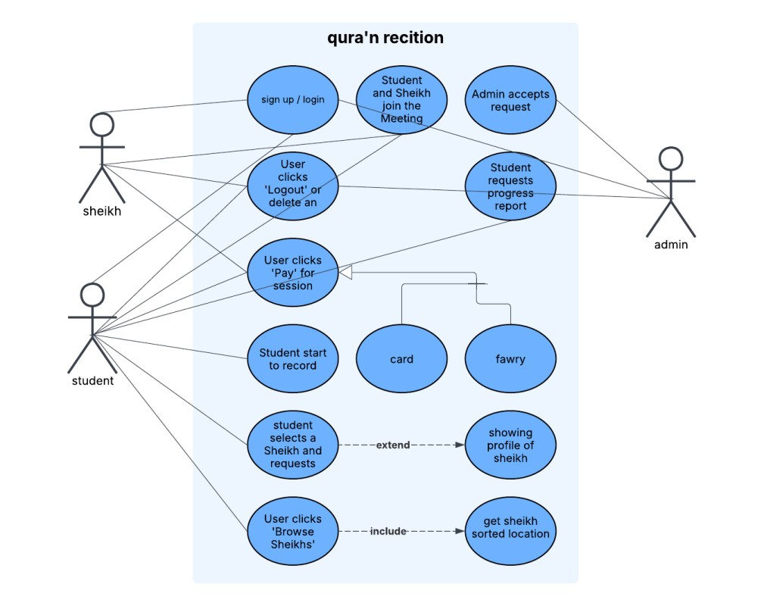

3.4. 3
ACTIVITIES Diagrams :

3.4.3.1 login and sign up
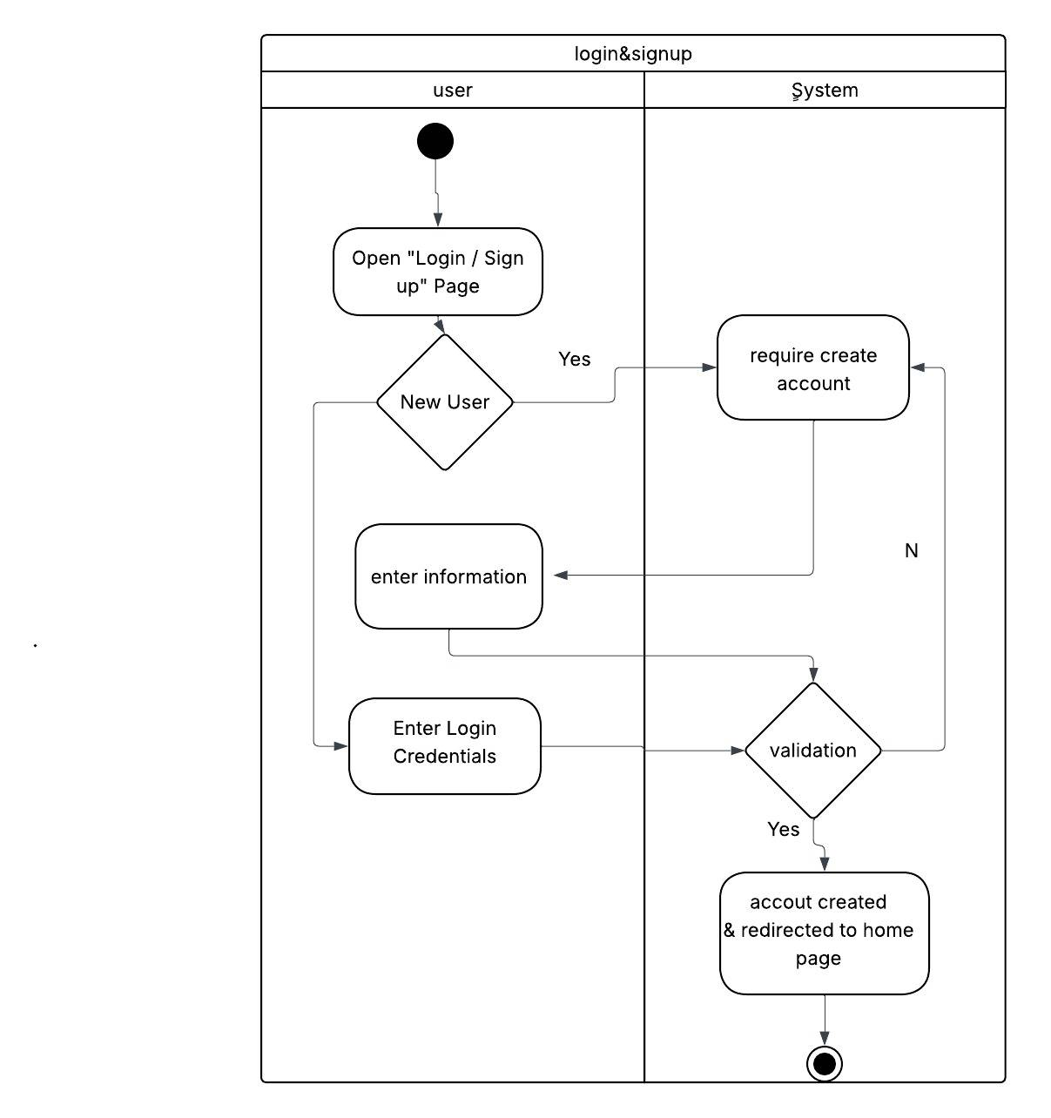
3.4.3.2 admin approval sheikh 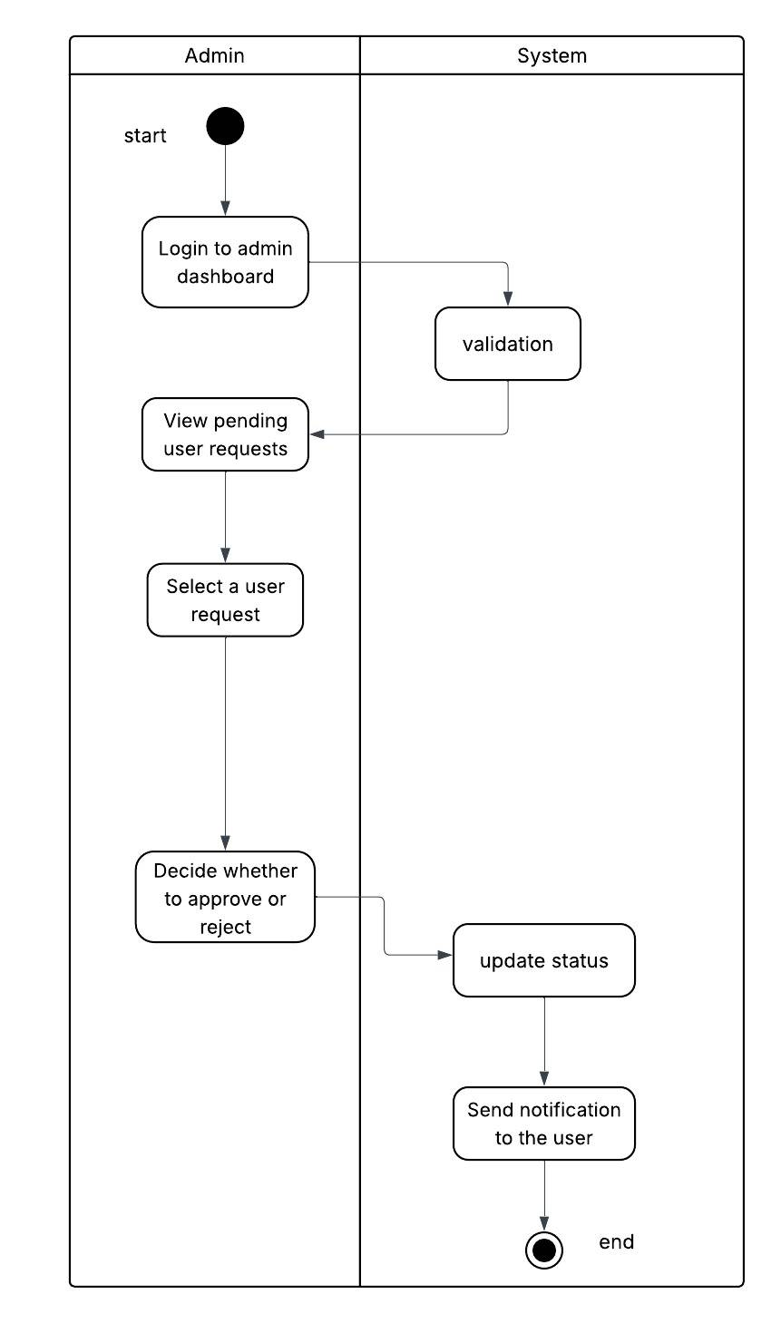
3.4.3.3 browse sheikhs 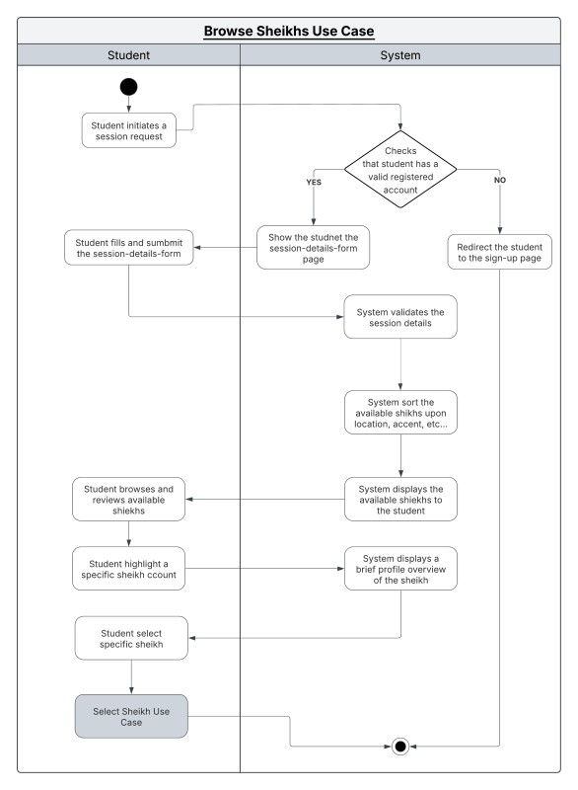

3.4.3.4 select sheikh and start session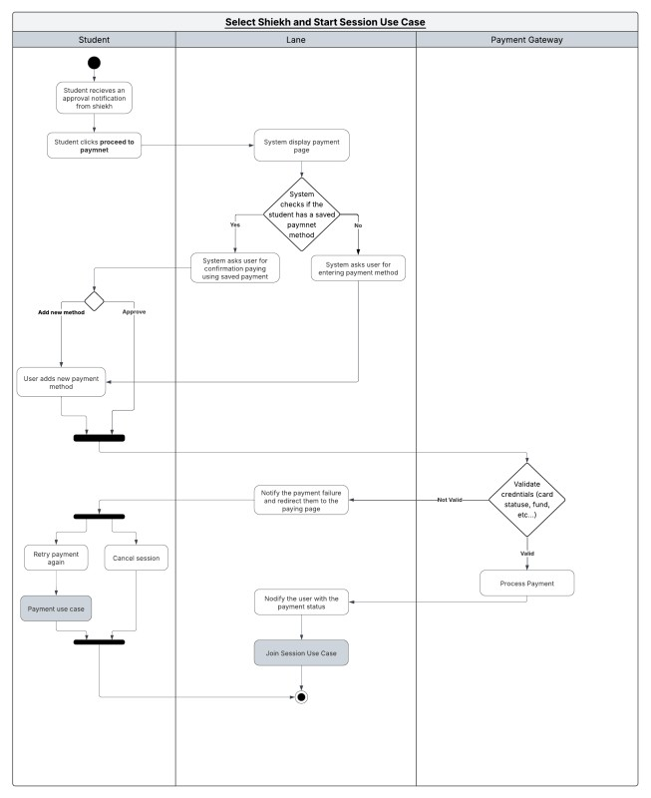

3.4.3.6 sheikh and student join meeting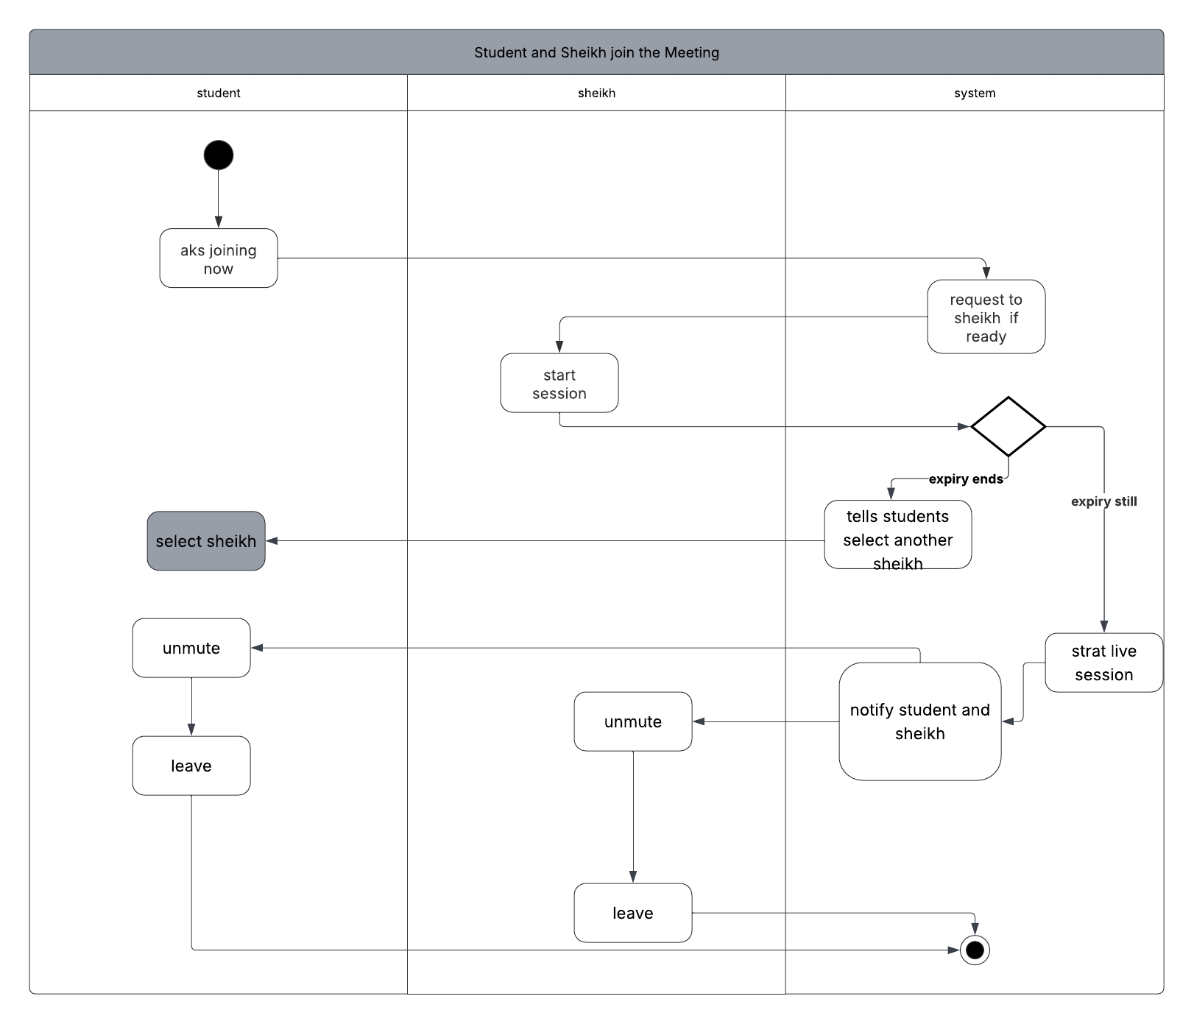

3.4.3.7 sheikh and student join 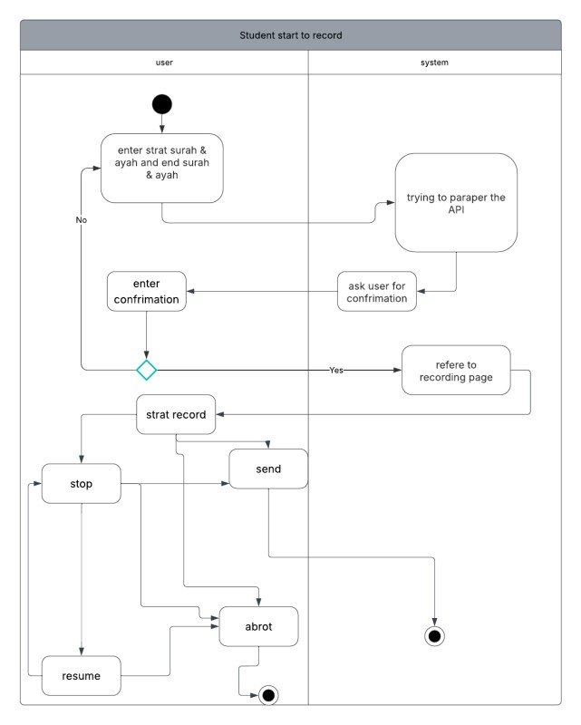

3.4.3.7 sheikh and student join
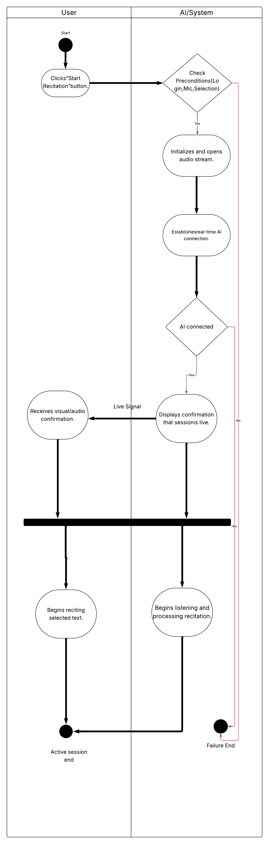
3.4.3.9 user logout or delete account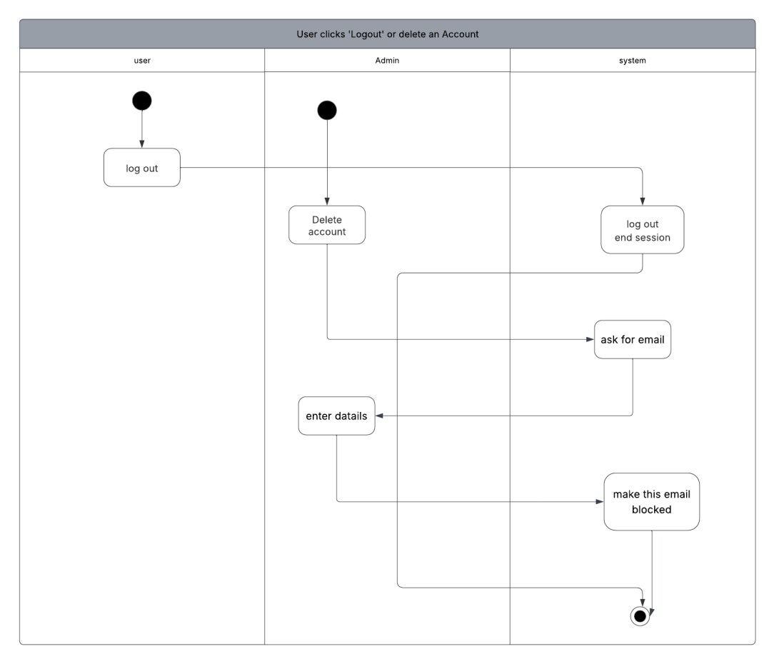

3.4.4.1 use case description payment
Field | Description
Use Case Name | Student Pays for a session
Triggering Event | - The shiekh approves the student’s session request, and the system prompts the student to proceed with payment
Actors | - Student  - Payment Gateway
Pre-Conditions | - A session request must exist and be approved by the Sheikh.  - System must have a configured and available payment gateway.  - Student has access to a valid payment method.
Post-Conditions | Succeful Outcomes:  - Payment is processed successfully.  - Session becomes confirmed.  - Both student and Sheikh receive confirmation notifications.  Unsuccessful Outcome:  - Payment fails, and the session remains pending payment.  - Student may retry payment.
Flow of Activities | Student | System
Flow of Activities | - Student opens the session approval notification.  - Student chooses payment method (card, wallet, etc.).Student wiats for a respons  - Student enters payment details and confirms payment.  - Payment Succeeds.  - Payment fails. | 1.1System displays the payment page with session details and amount.  2.1 System redirects securely to the payment gateway.  3.1 Payment gateway validates card/wallet details.  3.2 Payment gateway returns a success/failure response.  4.1 System marks session as Confirmed.  4.2 System sends confirmation notifications to student and Sheikh.  4.3 System stores the payment transaction securely.  5.1 System displays failure message and retry option.
Exception Conditions | 2.0 Payment gateway timeout/unavailable.  3.0 Payment declined (insufficient funds, card invalid).  3.1 Student cancels payment midway.

3.4.4.2 use case description Browse shiekhs

Field | Description
Use Case Name | Student Browses a Sheikh
Triggering Event | - The student initiates a request to book a Quran recitation session.  - The student enters the required session details (e.g., duration, date, recitation level).
Actors | - Student
Pre-Conditions | - The student must have a valid registered account.  - The system has stored Sheikh profiles with availability, location, and accent information.
Post-Conditions | - A list of available Sheikhs is displayed to the student.
Flow of Activities | Student | System
Flow of Activities | - Student initiates a session request  - Student reviews the available Sheikhs. | 1.1 System Displays the session information form.  - System displays a brief profile preview of the currently highlighted Sheikh.  2.2 System waits for the student’s selection.
Exception Conditions | 1.0 Student does not have an account or is not logged in.  2.0 No available Sheikhs meet the criteria.  2.1 System informs the student: “No sheikhs currently available for your criteria.”  2.2 System fails to correctly sort or retrieve Sheikh data due to internal error.

3.4.4.3 use case description select sheikh

Field | Description
Use Case Name | Student Selects a Sheikh and Requests a session
Triggering Event | - Student selects a Sheikh from the Browse screen and clicks “Request Session”.
Actors | - Student  - Sheikh
Pre-Conditions | - Student has already viewed Sheikhs (Use Case 3 completed).  - Student is logged in.  - Sheikh is available for the requested time.
Post-Conditions | - The selected Sheikh is requested for a session.  - The Sheikh receives a notification containing the session details.  - The student will later receive an approval/refusal notification.
Flow of Activities | Student | System
Flow of Activities | - Student fills in required session details  - Student browses and selects a shiekh  - Student wiats for a respons | 1.1 System validates the entered details.  1.2 System checks Sheikh’s availability for selected time.  2.1 System creates session request record.  2.2 System sends notification to the Sheikh.  2.3 System shows confirmation to the student.  3.1 System notifies student of the Sheikh’s approval or refusal when available.
Exception Conditions | 1.0 Student submits incomplete or invalid session details.  2.0 No available Sheikhs meet the criteria.  2.1 System informs the student: “No sheikhs currently available for your criteria.”  2.2 System fails to correctly sort or retrieve Sheikh data due to internal error.  3.0 System displays a general error message and logs the incident.  3.1 Network or server failure during request submission.

3.4.5 State machines
3.4.5.1 sheikh 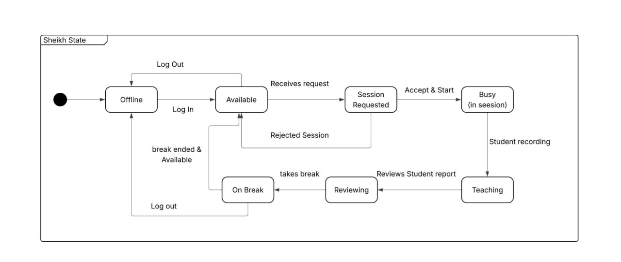3.4.5.2 session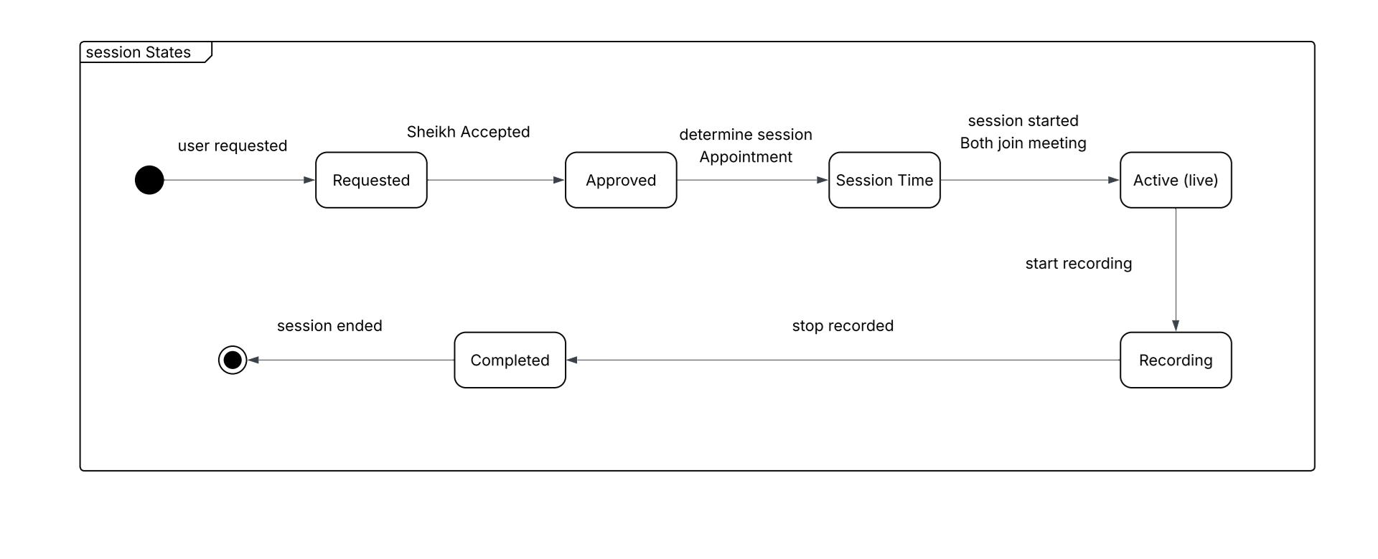

3.4.5.3 record
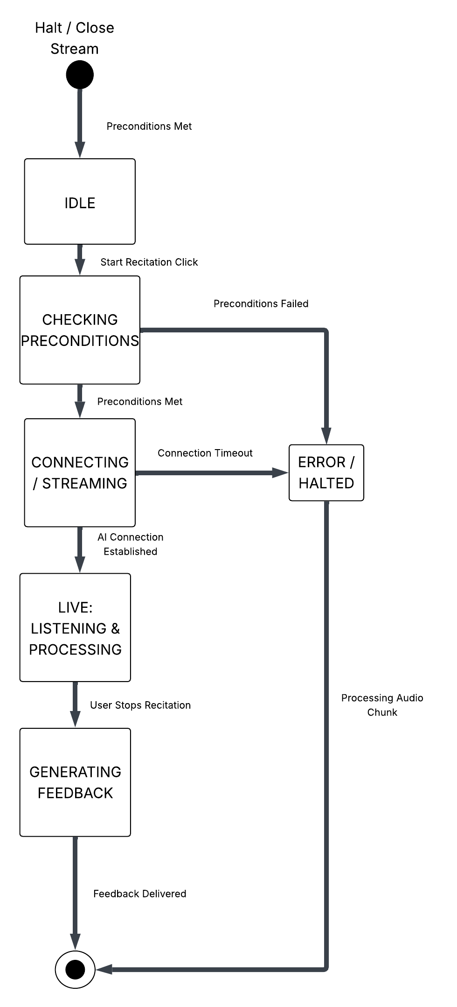
3.4.5.4 payment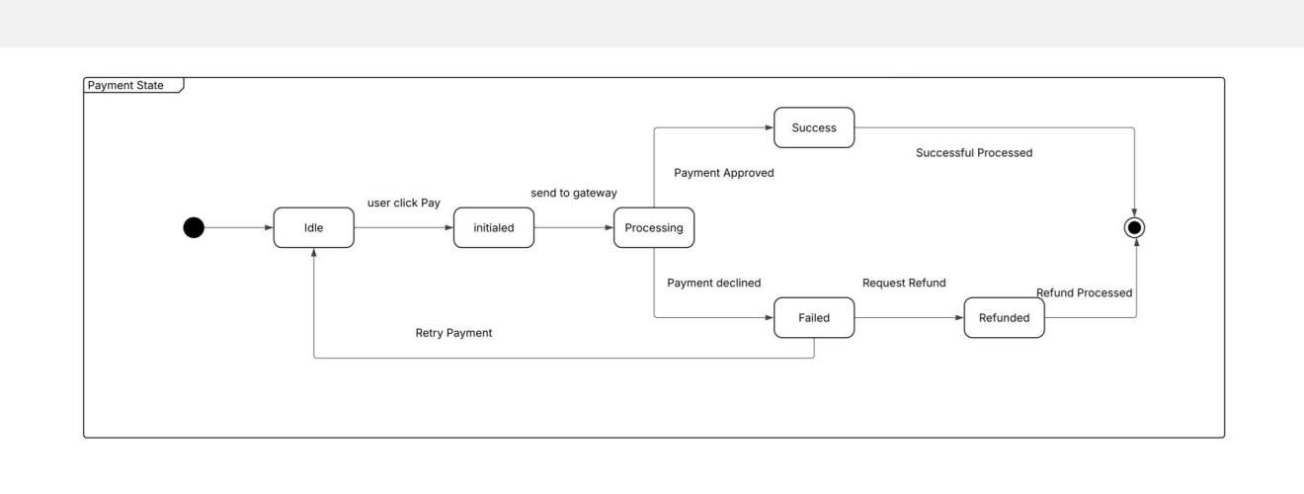
3.4.6
Sequence diagrams
3.4.6.1 sequence admin
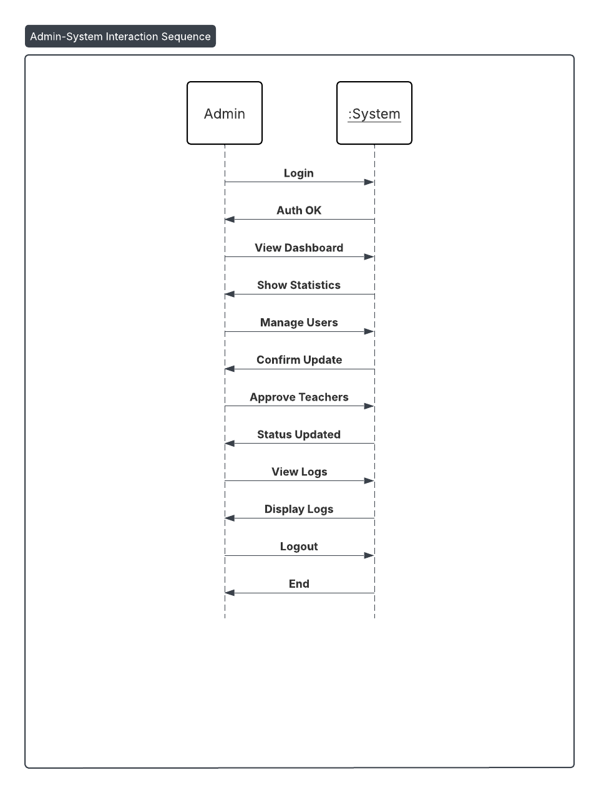

3.4.6.2 sequence student
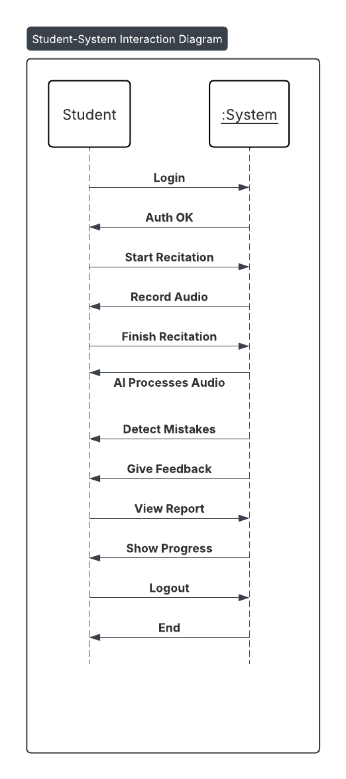

3.4.6.3 sequence sheikh
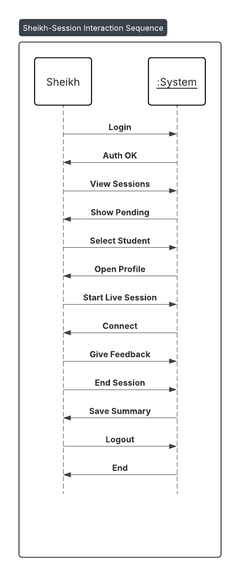

3.4.7 Data flow Diagrams
3.4.7.1
DFD level 0
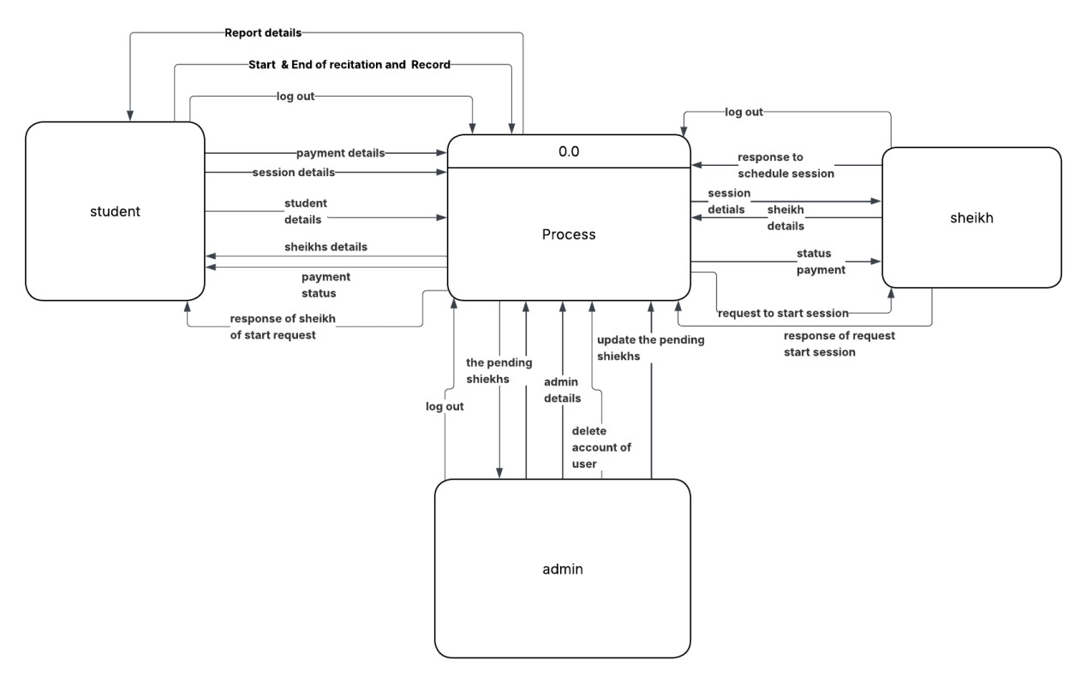

3.4.7.2 DFD LEVEL 1
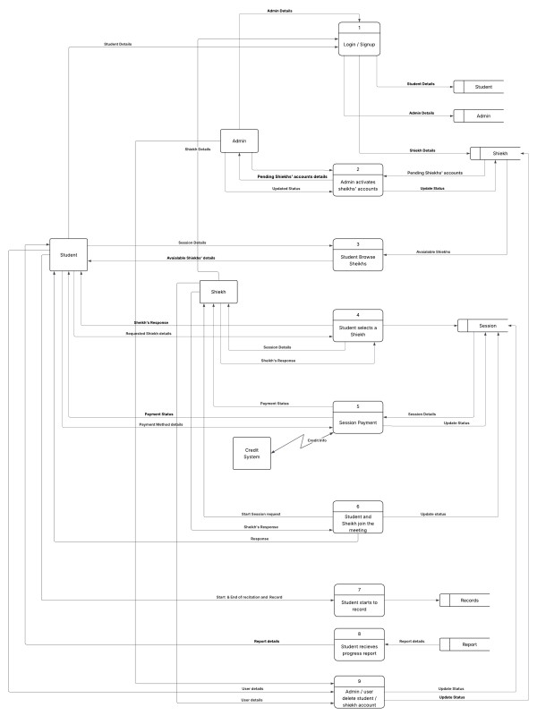

3.4.7.3 level 2
3.4.7.3.1
Level 2 DFD admin activate
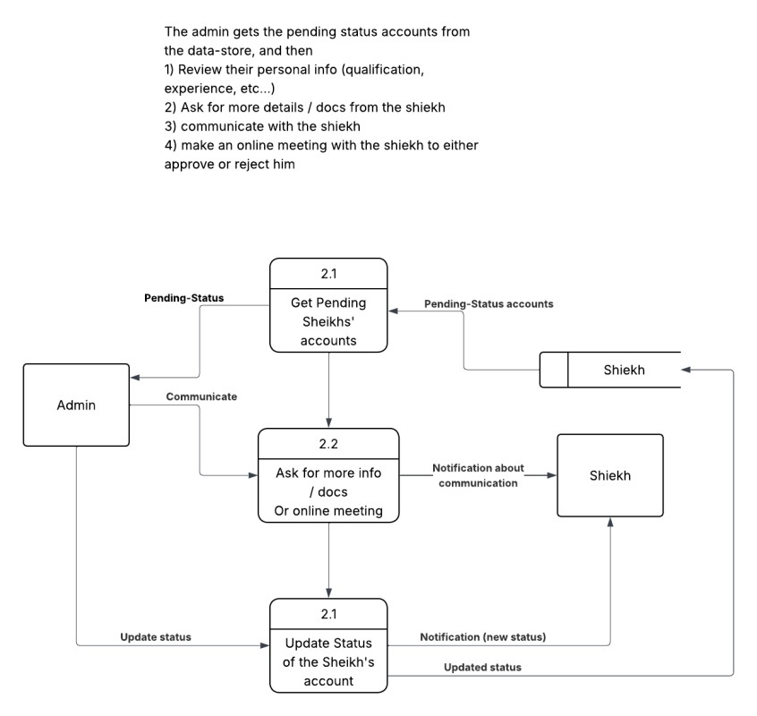

3.4.7.3.2
Level 2 DFD browse the sheikh
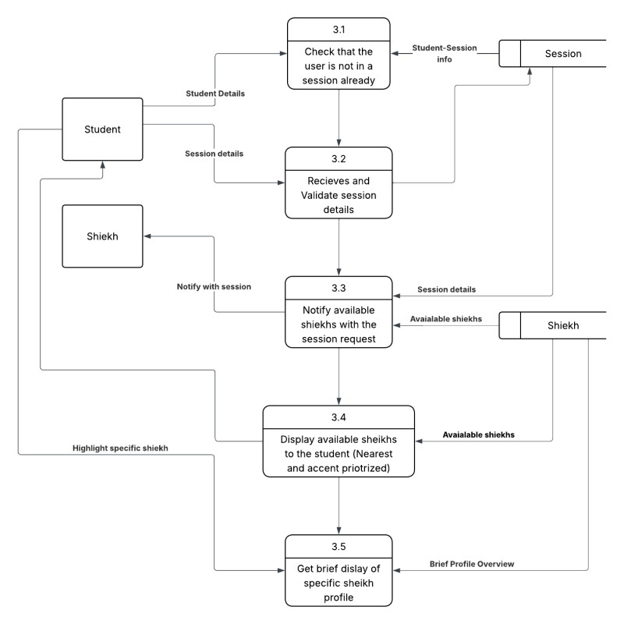

3.4.7.3.3 level 2 DFD select sheikh
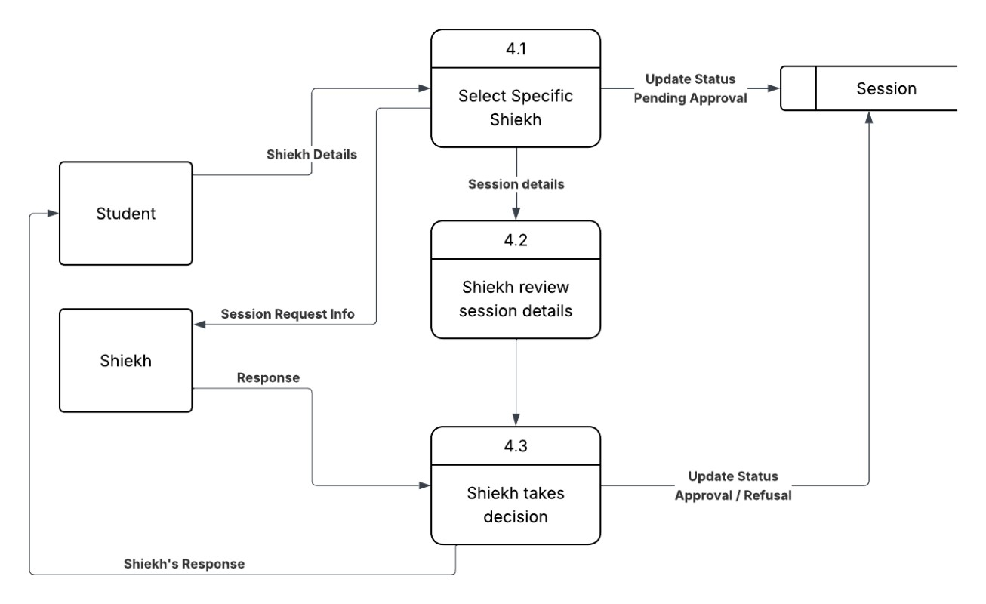
3.4.7.3.4 level 2 dfd student and sheikh 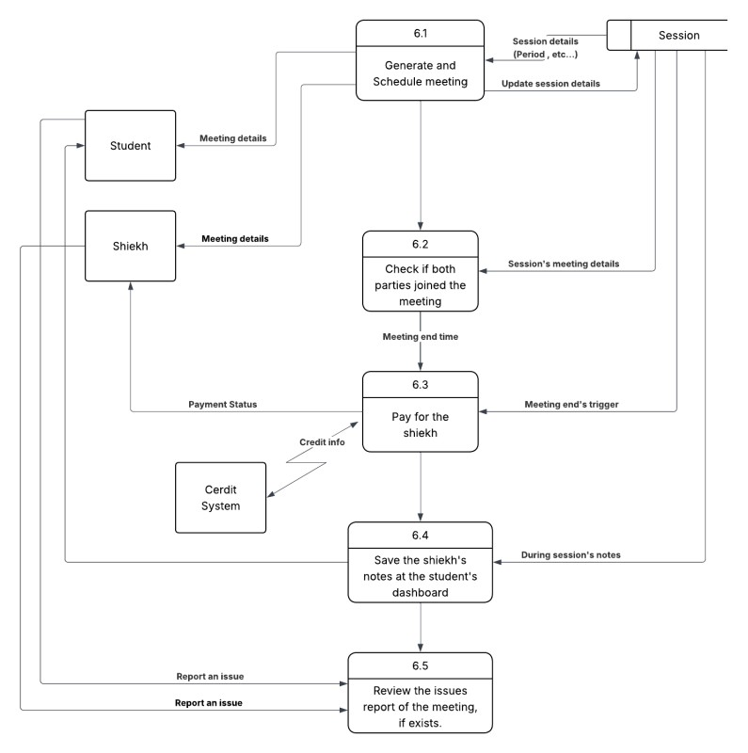

3.4.7.3.5 level 2 dfd payment
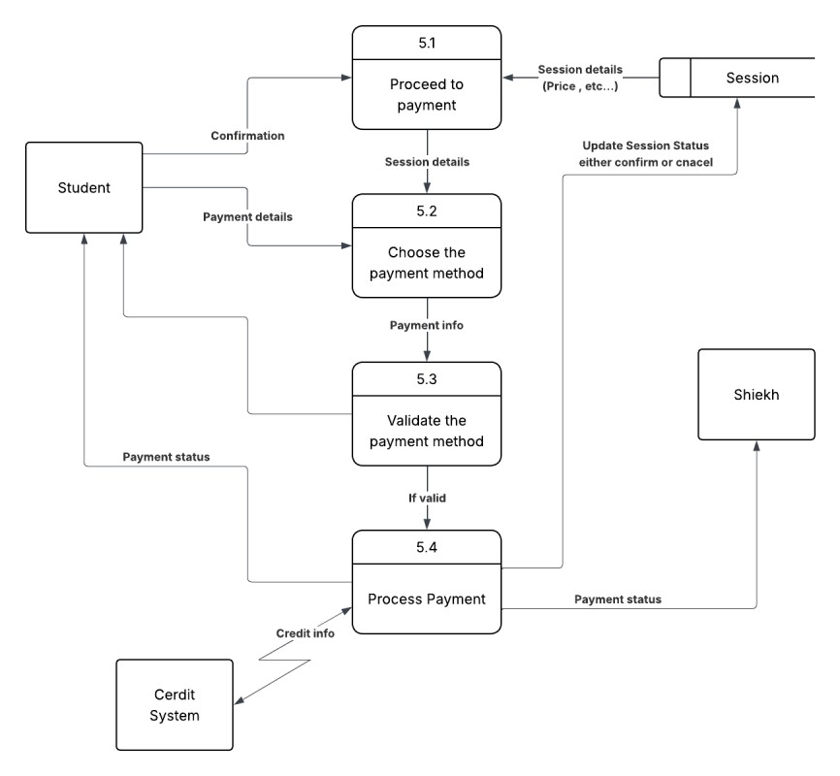

3.4.7.3.6 level dfd 2 AI report
